Executive Summary
This submission models the Northwest European petrochemical sample as a directed graph where each node is a representation of a side and commodity pair, e.g. naphtha at Moerdijk. Each “edge” records the evidence behind that connection. Using this graph, the model traces cracker naphtha supply back to upstream crude and tests how flows respond when a facility, pipeline, or waterway goes offline.
Because the sample data covers only a fraction of the real physical network, most links have to be inferred. The core design goal was to keep those inferences explicit. The main takeaway from the scenario analysis is a practical warning: whether a shock appears to cause a physical shortage at a steam cracker depends more on which inferred transport modes we include in the graph than on the shock itself.
Modelling (Question 1)
The model has four distinct entities:
- Facility – a physical site with a location and a status
- Unit – belongs to one facility and does the actual processing work. Each unit type consumers and produces specific commodities, i.e., a distillation unit turns crude into naphtha, and a cracker turns naphtha into ethylene
- Transport – physical infrastructure such as a pipeline
- Edge – “claim of transfer”, where a commodity can move from one place to another. It carries the transport mode, distance, capacity limit, assets and units it depends on, and its provenance
Facilities, units and pipelines keep the identifiers they have in the data: facility id, the unit id and the pipeline UUID. Each unit points to its facility. Ports act as connectors: their import and export terminals handle crude and naphtha rather than transforming them. A facility's role is derived from its units rather than stored.
The central design choice is the unit of the graph. A node represents one commodity at one site, such as “naphtha at Moerdijk”. Units become edges inside a site, for example crude at a refinery to naphtha at the same refinery. Subsequently, this has three critical advantages: i) an integrated refinery and cracker on one site needs no special treatment, ii) a single unit can be switched off without touching the rest of the site, iii) tracing become a backward walk that stays within one commodity and crosses to another only through a unit.
Therefore, a node is identified by a facility id plus a commodity. An edge is identified by its two nodes plus a key, because two sites can be linked in more than one way, for example by pipeline and through a port. Points where a pipeline leaves the sample get their own boundary nodes, named after the line and its end coordinates.
Illustrative Path:
Seaborne Crude → [sea lane] → Rotterdam Port → [pipeline] → Shell Pernis (CDU: crude → naphtha) → [pipeline]→ Moerdijk Cracker
Each path has an embedded scoring system where the weakest link score is picked up. The Pernis-Moerdijk naphtha pipeline leg scores 0.6 (according to the confidence table below), and the full path scores 0.5 because the seaborne leg into Rotterdam is inferred (weakest link in command).
Building a Map from Partial Data (Question 2)
It is imperative to not allow an ‘inferred’ connection to be mistaken for a mapped one and to avoid conflating the infrastructure, “edges” are constructed in strict order of evidence strength. Each edge carries an explicit provenance label and a confidence rank as shown below:
Evidence Tier | Rule / Example | Confidence
1. Facility Unit Data | Internal on-site unit conversion (e.g., crude -> naphtha inside a refinery) | 1.0
2. Direct Pipeline Match | Pipeline segment endpoint lies within ≤ 4 km of a commodity-compatible site | 0.8
3. Gap-Bridged Pipeline | As above, routed across a gap of ≤ 5 km between consecutive GeoJSON fragments | 0.6
4. Spatial Proximity | Port-to-port sea lanes, port-to-site within ≤ 15 km, co-located sites within ≤ 2 km | 0.5
5. Reference / Fallback | Navigable inland barge corridors (0.3), last-resort fallback to nearest ports (0.2) | 0.2 – 0.3

Four rules can be inferred:
- Commodity compatibility comes first: A pipeline endpoint can only snap to a site whose units produce or consume that commodity.
- Endpoint-only snapping: A pipeline that merely passes near a site without terminating there does not connect to it
- Open-ended lines become boundary nodes: Pipeline segments extending out of the sample area (such as the eastern crude/product lines into Germany) are retained as boundary nodes with halved confidence since flow direction is unobserved
- No stranded sites: any supply or demand site still lacking an outbound or inbound link receives a clearly labelled assumed link to its nearest ports. This catches Zeeland Refinery and Chemelot-Gellen.
Every record and setting is checked against a schema when it is loaded, using Pydantic. A row with an impossible value, such as a latitude above 90 degrees, a non-positive capacity or an unknown unit type, is set aside and reported, so one bad row neither stops the run nor slips into the graph.
Sensitivity analysis
Because distance cutoffs (4 km endpoint match, 5 km gap bridge) are engineering judgements, a sensitivity analysis was run across 2–6 km endpoint radius and 3–8 km gap bridges: The Pernis → Moerdijk naphtha pipeline link holds across every parameter combination tested. The Rotterdam → Pernis crude pipeline link requires at least a 4 km endpoint radius. Whilst the Rotterdam → Exxon Botlek crude link only connects via pipeline when gap bridging is widened to 8 km.
For missing barges and sealines modes, three small reference tables encode basic regional geography (labelled as 0.3–0.5 assumptions): shared inland waterways (barge), port sea-access dependencies, and coastal waypoints (sea lane). Routing along actual water waypoints rather than straight lines is essential for scenario analysis: a straight line into Rotterdam would falsely draw over the Western Scheldt (Westerschelde) that a Rotterdam-bound vessel never enters in reality!
The transport data alone takes the provided map and modifies it according to these 4 steps:
- Pipeline fragments drawn as delivered (orange)
- Each site is coloured by the role which is derived from its units
- A short link from every pipeline end to the site it was matched to is drawn
- Sea lanes and port-to-site links are added to link port terminals
See modified map in the ANNEX section of this report.
Scenario Analysis (Question 3)
Identifiable possible disruptions: a facility outage, a partial outage at reduced capacity, a pipeline taken out of service, a blocked chokepoint, or a closed region.
This analysis is architected in such a way where each scenario works on a copy of the graph and logs exactly what it removed and why. Scenarios are themselves validated data, so a request from an interface or a file is checked before it touches the graph.
Baseline vs Disruption Output
Using a minimum-cost network flow solver (routing crude to refineries, capping naphtha output by refinery run rate, and routing naphtha to crackers), the table below compares cracker naphtha shortfalls (in kt/year) under five disruptions on the full graph including inferred barges and secondly on the mapped data + local port links only.
The solver receives three sets of inputs: 1. Capacities on ‘edges’: terminal capacities from the port units. 2. Sources: each refinery suppliers its distillation capacity times an assumed naphtha yield, and seaborn imports are available at a cost premium 3. Sinks: each cracker’s naphtha demand is derived from its ethylene capacity.
The solver returns a flow on every edge. That output is interpreted in two ways. First, each cracker's intake is attributed to its original suppliers, assuming product blends at every node. Second, I report on unmet demand and refinery run rates.
A comparison shows the log of what the shock removed, unmet demand per cracker, each cracker's supplier mix before and after, refinery run rates, and the largest changes in flow by route. Every run is stored with a fingerprint of its input data, settings, solver version and scenario.
It first routes crude to refineries. Each refinery's resulting run rate then limits its naphtha output, and the naphtha goes to crackers by the cheapest route. The shortfalls below are modelled in thousand tonnes per year:
Disruption Scenario | Cracker Shortfall — Full Graph (inc. Inferred Barges) | Cracker Shortfall — Package Data Only (No Barges)
1. Shell Pernis Refinery offline (100%outage) | 0 kt/y | 1,947 kt/y (Moerdijk)
2. Shell Pernis derated to 40% capacity | 0 kt/y | 1,057 kt/y (Moerdijk)
3. Pernis–Moerdijk naphtha pipeline offline | 0 kt/y | 1,947 kt/y (Moerdijk)
4. Western Scheldt (Westerschelde)closed to shipping | 1,684 kt/y (Dow Terneuzen) | 6,789 kt/y (regional)
5. Antwerp port zone closed | 0 kt/y | 1,279 kt/y

Without barge links, Moerdijk appears entirely dependent on the Pernis pipeline, because its only alternative is a port terminal of about 0.7 million tonnes a year, suffering 1,947kt/y deficit if the pipeline goes down. However, with the ARA barges Moerdijk reroutes waterborne naphtha from other regional refineries with zero shortfall.
Global chokepoint illustrations
To illustrate a distant shock, the seaborne crude source has been replaced with two invented exporters, one in the Gulf (routed through Hormuz, Bab el-Mandeb and Suez) and one in the North Sea capped at 40 million tonnes a year. Closing Hormuz then cuts 37.8 million tonnes a year of crude: BP Rotterdam falls to 77% of its target intake, the Antwerp and Zeeland refineries stop, and naphtha imports rise from 0.6 to 5.0 million tonnes a year to keep the crackers supplied. These numbers follow from assumed capacities for the purpose of modelling.
The same graph supports pricing. Mode and distance on each edge are the basis of freight and landed-cost estimates, and a disruption that moves a cracker's marginal supplier from a local refinery to seaborne imports signals that its delivered price will move towards import parity.

ANNEX:
Redesigned Map:
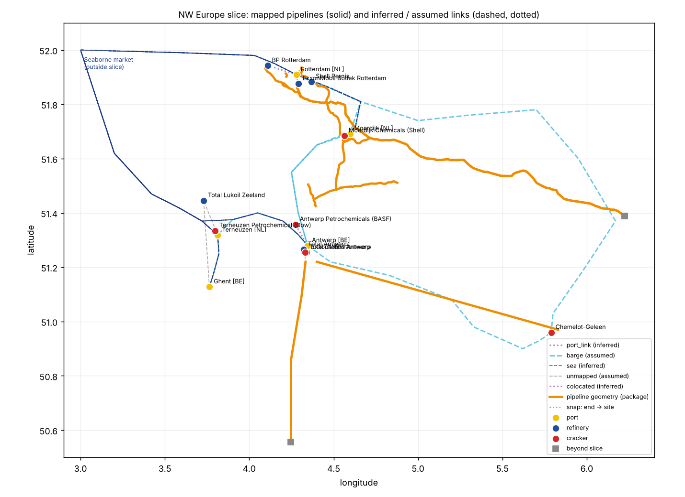
Key decisions:
Decision | Approach | Main alternative | Why | What would change it
Unit of the graph | One commodity at one site | One node per facility | Handles integrated sites and unit outages without special cases | A scope that never needs unit-level detail
Matching pipelines to sites | Fragment ends only, within 4 km, commodity-compatible sites only | Any point on the line, wider radius | Fewer false connections; every match is logged and auditable | Site outlines or operator endpoint data
Missing transport links | Infer, label and score them; never drop a site | Use mapped data only | A graph with silent gaps understates supply options | A real inland-waterway and shipping network
Co-located Antwerp records | Keep them separate, linked by inferred edges | Merge into one integrated site | Preserves the source records and keeps the ambiguity visible | Ownership or site-boundary data
Where a scenario applies | Between graph build and solver | In the data or inside the solver | Clean baseline, solver stays a black box, full audit log | None foreseen
Validation | Schema checks records, settings and scenarios | Checks scattered through the code | Bad inputs are caught once, at the boundary, with clear messages | —
Upstream oil fields | A boundary node, plus one clearly invented illustration | Populate real fields with guessed volumes | Avoids presenting made-up data as fact | Real field and export-terminal data

Limitations and next steps:
The customized solver leveraged finds the cheapest route, not the most likely one, and uses illustrative costs. Port capacities cover all cargo, pipeline capacities are unknown, and sea and barge routes are approximations. The most valuable additions would be a real inland-waterway network, then pipeline endpoint and operator records, then facility outlines in place of single points; the coverage comparison suggests these would change the answers more than any refinement of the model.

